Quality Policy
The ARC Team within Cardiff Council is firmly committed to the delivery of high quality, cost-effective and efficient services that meet the needs and the expectations of our customers and the community that we serve.
We are committed to providing services in accordance with the ISO9001-2015 Standards.
We will consult widely with our customers, interested parties and staff to identify the internal and external issues and accommodate them within the constraints of legislation and available resources and will seek to continuously improve the quality, extent and nature of the services provided, increasing brand awareness, reputation and revenue.
We recognise that every employee, through their day to day work, makes a key contribution to the overall delivery of Council Services, whether they are delivered internally or externally, and we will not only encourage their participation in the preparation, implementation and evaluation of improvements activities but also their individual employee development.
We will publish our quality policy to our Cardiff Improvement site and all managers will be responsible for reinforcing a culture of excellence with the organisation's people.
We are committed to the continual improvement of the Quality Management System.
The quality policy will be reviewed annually as part of the management review to ensure it’s continued and relevance to the team, directorate and the Councils strategic objectives.
Lesley Ironfield
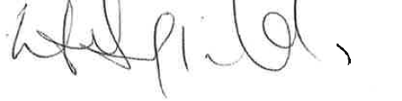
Operational Manager of Customer and Protective Services
Cardiff Council
Date: April 2025/2026

